Ref:- TMT/ +91 97676 86939/S0377/2025 10.7.2025

To
+91 97676 86939

Dear sir,

Sub: - SUPPLY OF TWO STATIONED HYDRAULIC BAGASSE BAILING PRESS MACHINE.

Thank you very much for your enquiry regarding your requirement of bagasse bailing press with two stages. We are glad to inform you that we would be in a position to supply you the required equipment. Given below are the required specifications and description of the machine and our terms and conditions.
PRICES
The cost of bagasse bailing press machine along with two stationed having capacity 8 to 10 MT/hour. Along with 40 HP Crompton Motor high speed high discharge hydraulic power pack, along with control panel for manual and auto operations is Rs 12,20,000/-
(Rupees Twelve Lakhs Twenty Thousand Only)
LIST OT EQUIPMENT
- CORMPTON MOTOR 40 HP/AC 1 NUMBER.
- HYDRAULIC CYLINDERS 1 NOS.
- POWER PACK WITH HEAT EXCHANGER
- COMPLETE PIPING FROM HYDRAULIC UNIT TO PRESS
- ELECTRICAL PANEL WITH PROXIMITIES AND THERMO CONTORLLER.

TERMS AND CONDITIONS
The above price is ex-our works, Hyderabad.

- Taxes as applicable at the time of delivery.

b) DELIVERY: 5 Weeks from the date of your technical and commercially clear order along with advance.

c)PAYMENT: 50% value of the order as advance, and balance after inspection and prior to delivery.

d) GUARANTEE: should any part(S) prove defective in terms of design and workmanship, we agree to replace those parts that are manufactured by us or our subcontractors free of cost with in one year from the date of dispatch.

e) COMMISSIONING & ERECTION: we will supervise the erection and commissioning our equipment. The required manpower at your site will have to be provided by you.

f) VALADITY: Our offer is valid for your acceptance for 30 days more.

g) EXCLUSIONS: All civil engineering works at your site such as foundation work, foundation bolts, piping form your heat exchanger to our equipment, electrical connections to the equipment from your supply point provided by you.
We are sure will find our offer in line with your requirements. Should you require any further clarifications/details please contact us at 9849207176.
Thanking you and assuring you our best services.
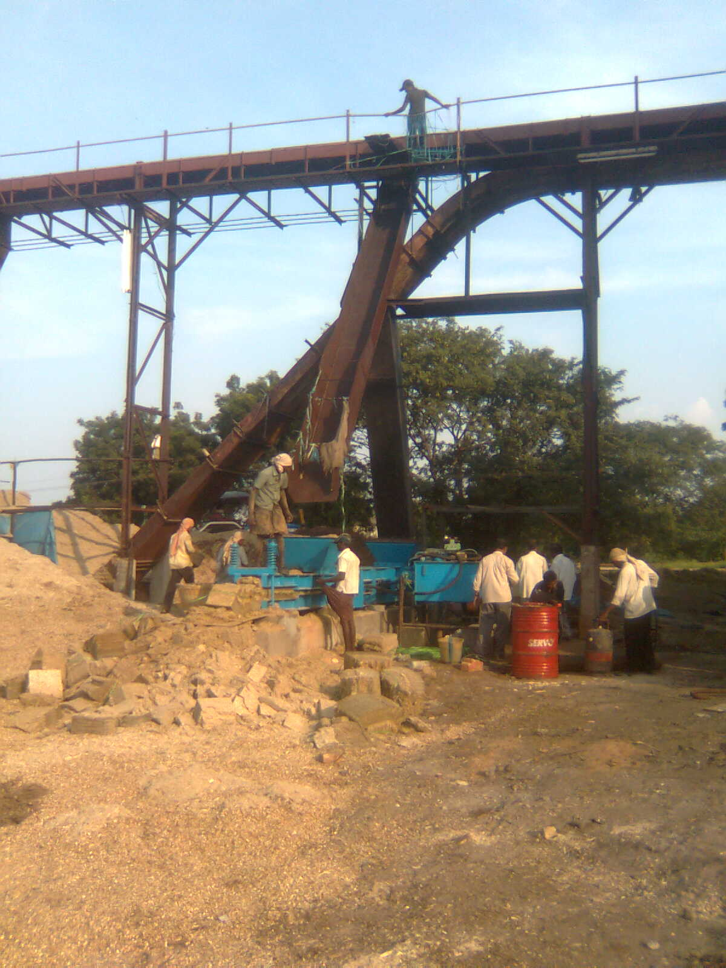

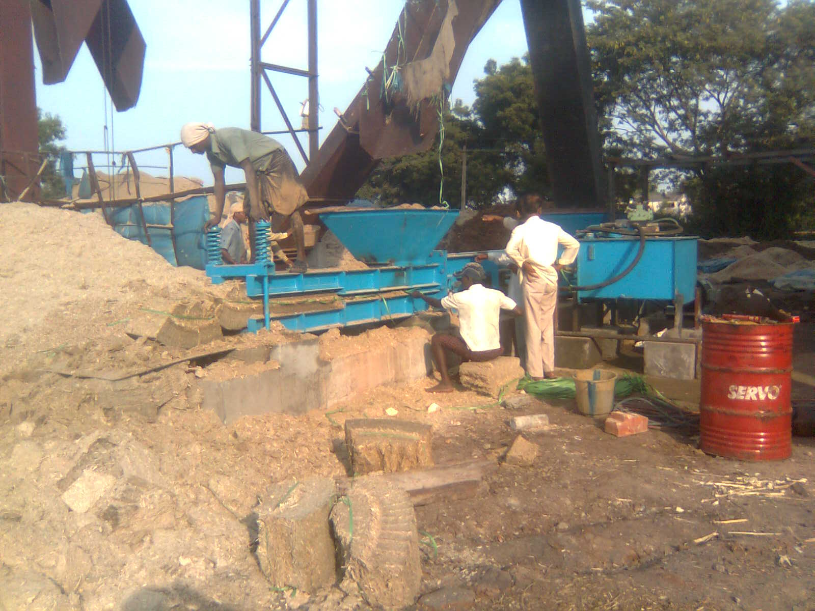

For TECHNO MACHINE TOOLS

( T. SIVARAMAKRISHNA)

